Jack Berberian

CIS 245

1/26/2022

The Grep Family Assignment

Somethings to know beforehand:

Grep signals the type of command and can be best described as a librarian looking for books or a searching program.

The end of the command requires GrepLab to signify where we want the command to run.

Ex: grep ‘Molly Weasley’ TestGrepLab

That command will search for Molly Weasley inside the single quotes with the file TestGrepLab and since there is no file called that, there will be no results. Be advised that it is case sensitive.

1. Print all lines containing the string Lane

Grep will search for the word ‘Lane’ inside the single quotes using the file GrepLab and it is case sensitive.

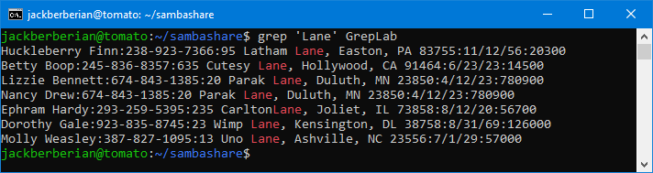

1. Print all lines where the person’s first name starts with H.

Grep will search for the letter H inside of the single quotes but since there is a ^, it’ll only look at the beginning of a line.

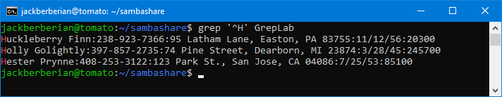

1. Print all lines ending in 200.

Grep will once again search for what’s inside the single quotes but this time it’ll only look at the end of the line because of the $.

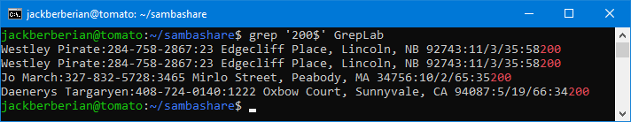

1. Print all lines that don’t contain 408.

The -v command inverts the search and instead of finding lines that do contain 408 inside, it’ll look for lines that don’t contain 408.

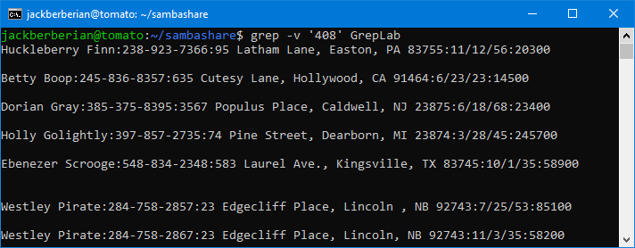

1. Print all lines where birthdays are in the year 1935. (be careful of the date format)

Here, the birthdays are in a format of (10/1/35:) so in order to find birthdays in the year of 1935, we can enter grep ‘/35:’ GrepLab which will print lines that follow that format which are only the ones that have birthdays in 1935.

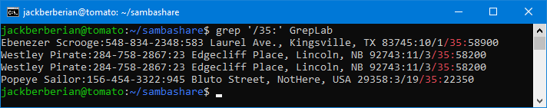

1. Print all lines where the phone number is in an area code that starts with an 8.

Since the phone number is in a First Name:000-000-000: format, grep searches for an 8 after a semicolon, 2 other numbers and then the final – in the format of the telephone numbers.

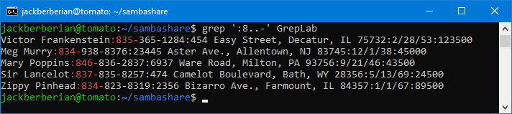

1. Print all lines containing an uppercase letter, followed by 5 lowercase letters, a comma, and one uppercase letter.

The [A-Z] in the brackets searches for 1 capital A-Z, similar for the lowercase A-Z, then the \{5\} then looks for 5 instances and by adding a comma, and a space along with the additional [A-Z} in the brackets, Grep then searches for a capital A-Z, lowercase a-z (with 5 instances), a comma, a space and an additional A-Z to find all the lines that containing an uppercase letter, followed by 5 lowercase letters, a comma, and one uppercase letter.

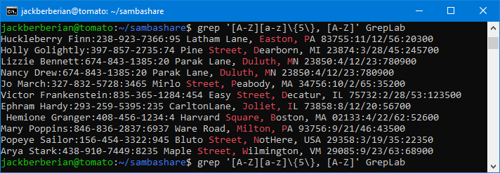

1. Print lines where the address begins with a two- or three-digit number (so this would be 12 Main St or 123 Main St but not 1234 Main Street)

Grep ‘:[0-9][0-9][0-9] ‘ GrepLab

Using the :[0-9[[0-9][0-9] command, Grep will search for a semicolon and then 3 series of digits, therefore finding an address that begins with a two or three digit number.

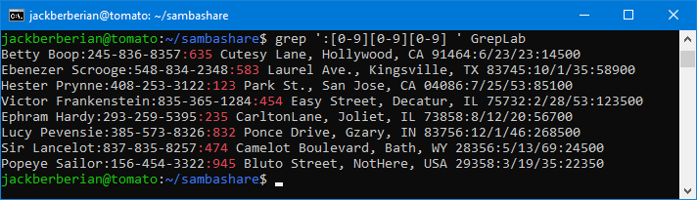

1. Print lines where the person lives in Mass or Illinois.

Using egrep ‘MA|IL’ GrepLab, we can search for lines where the person lives in Mass or Illinois. The | also know as a pipe command, lets us search for an additional item so we could also add ‘MA|IL|PA’ and it would also search for PA as well.

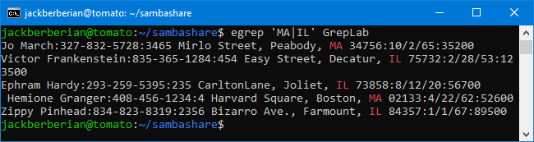

1. Print lines containing the address that aren’t on a street.

Here, you can enter the command grep -v ‘ Street,’ GrepLab

Using the -v flag, you can search the file for lines not containing Street therefore printing the lines containing the addresses that aren’t on a street.

Similar to the other question, the -v simply means to invert the command so instead of finding lines that contain ‘ Street,’ inside the single quotes, grep -v ‘Street,’ GrepLab will find lines that do not contain Street. Therefore finding addresses that aren’t on a street.

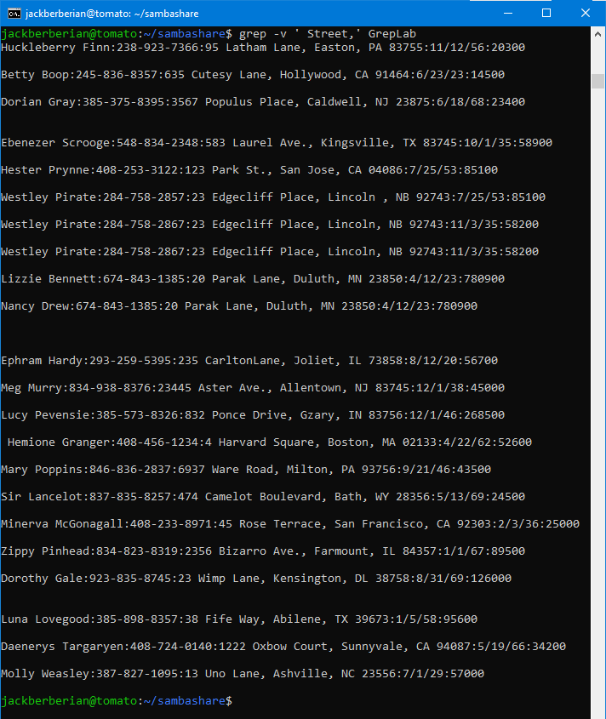

Citations:

<https://flylib.com/books/en/4.356.1.26/1/>

<https://flylib.com/books/en/4.356.1.27/1/>

<https://flylib.com/books/en/4.356.1.30/1/>

<https://flylib.com/books/en/4.356.1.29/1/>